Linux Assignment 1

1. Print the system information and the Linux server release name.

Command: cat /etc/os-release

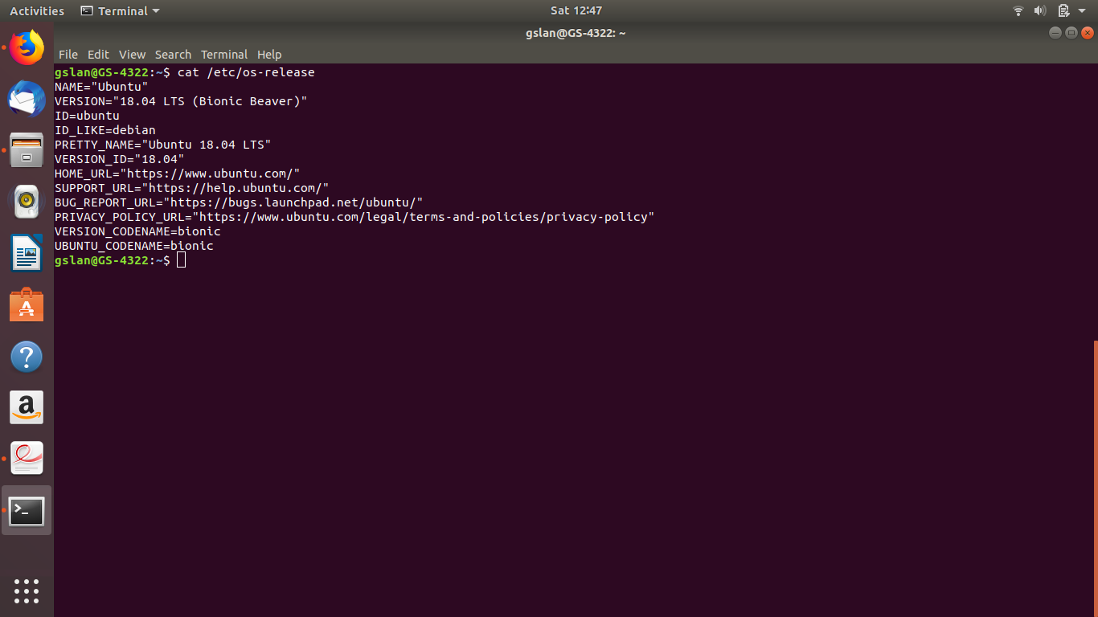
2.Display the user with witch you have logged in.
Command: who , whoami

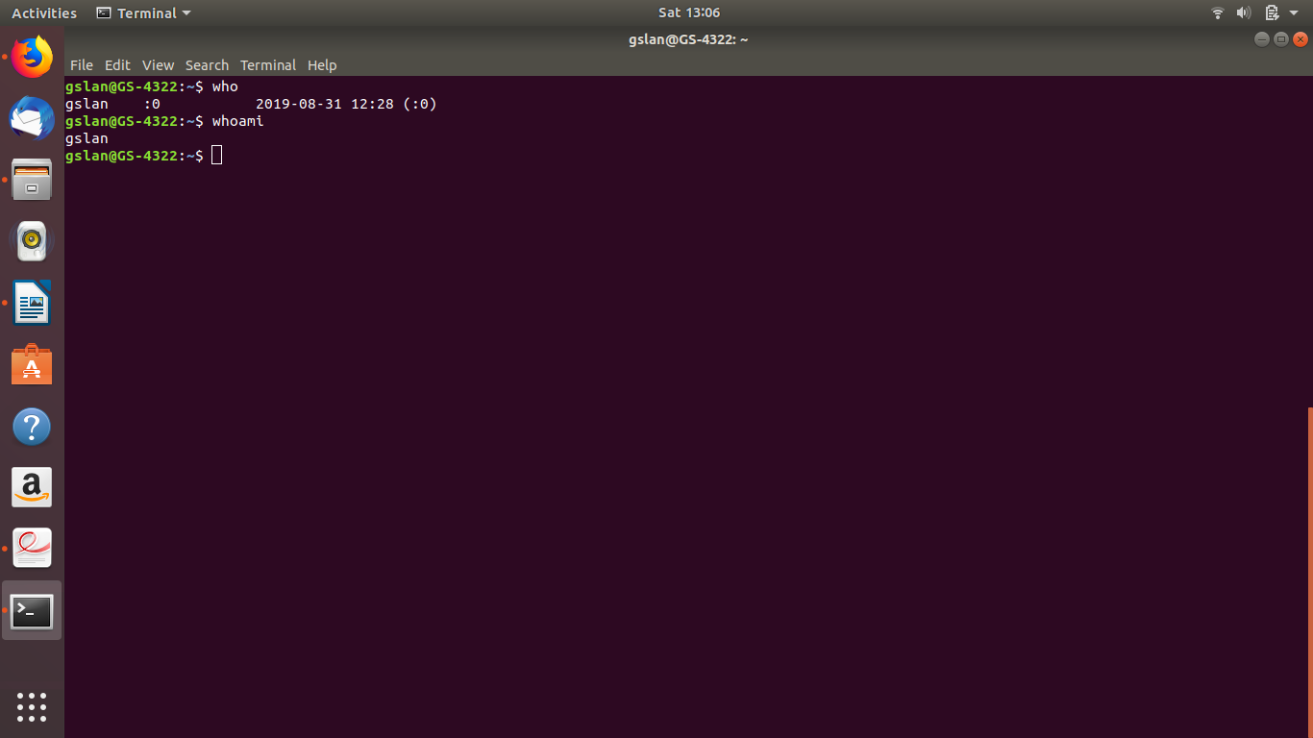

3. List all the files in your home directory including hidden files

Command: ls -a

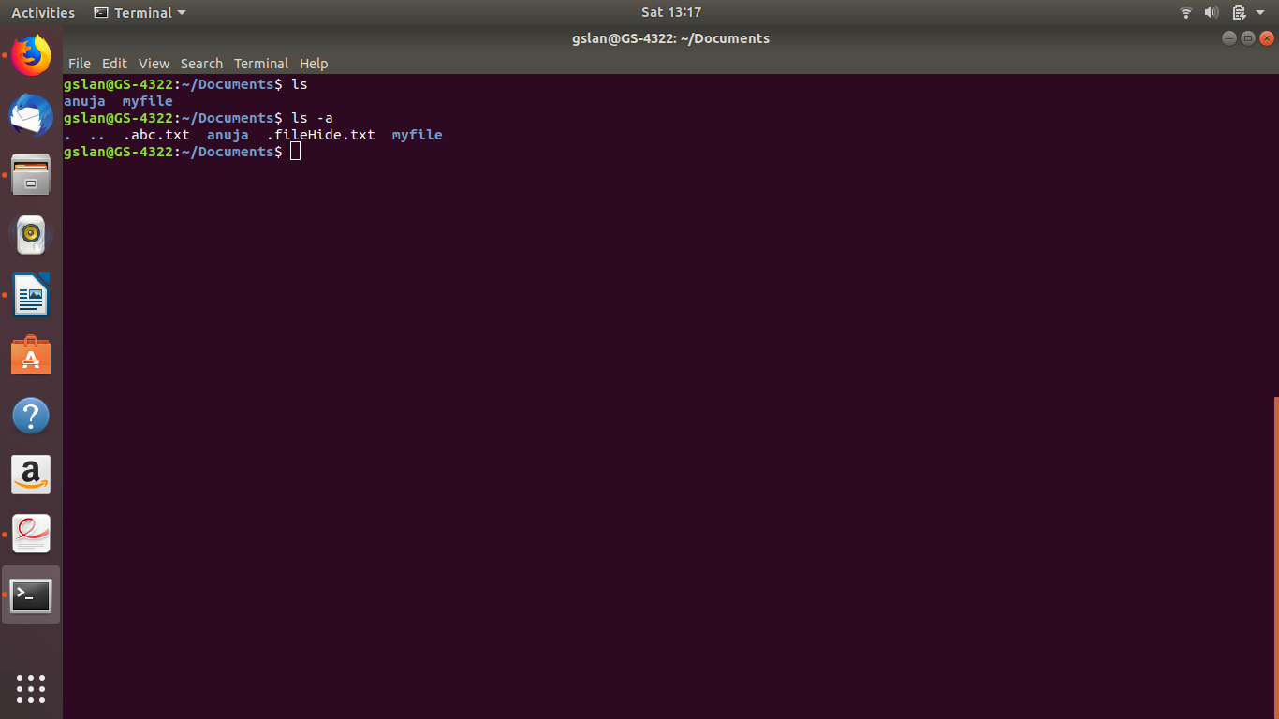

4.List the files in \boot in human redable format

5. Display the first 12 lines of /etc/services
Command: head -12 /etc/services
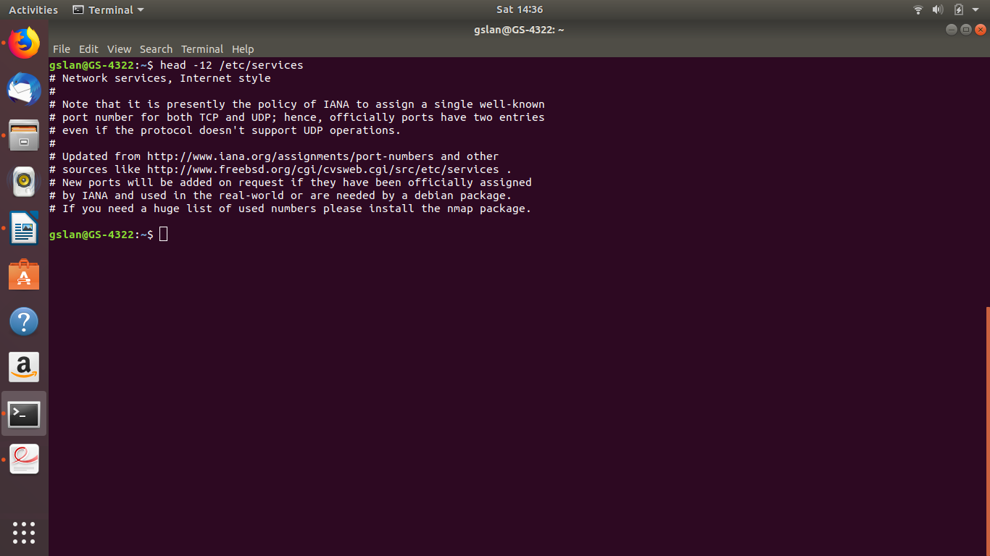
6. Display the last line of /etc/password
command: tail -1 etc/passwd

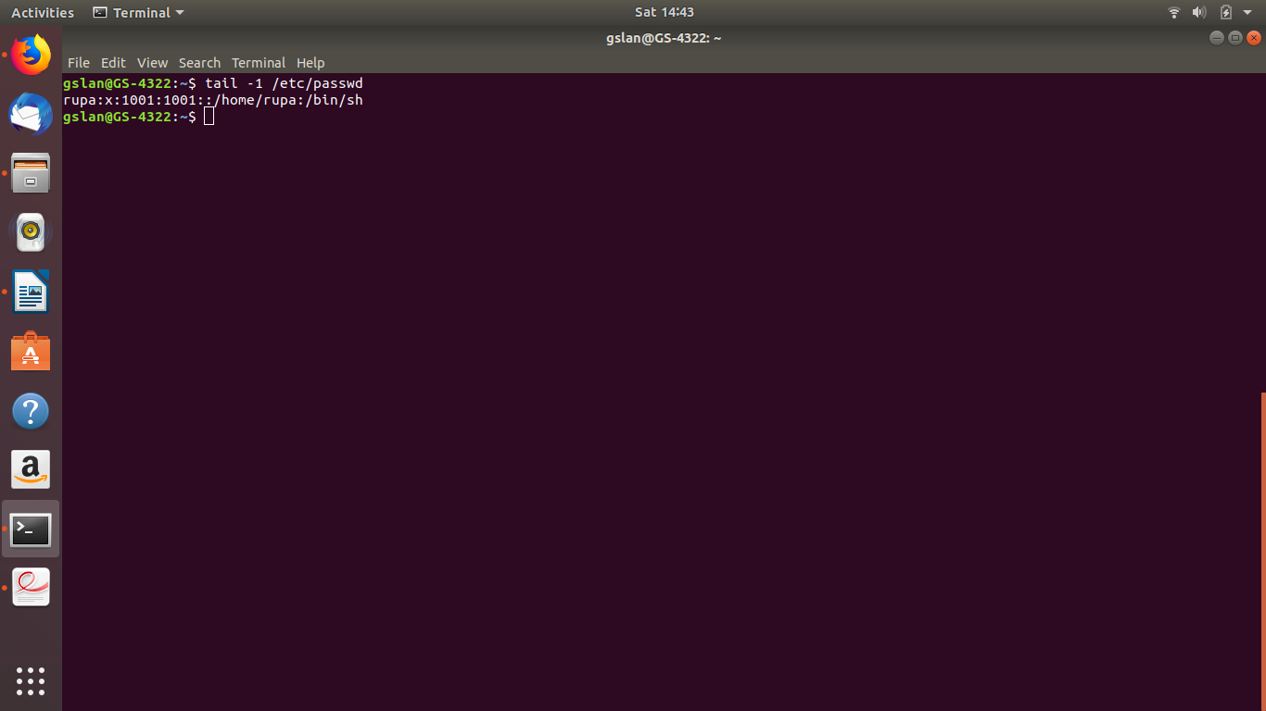
7. List the partition type and list the partition table
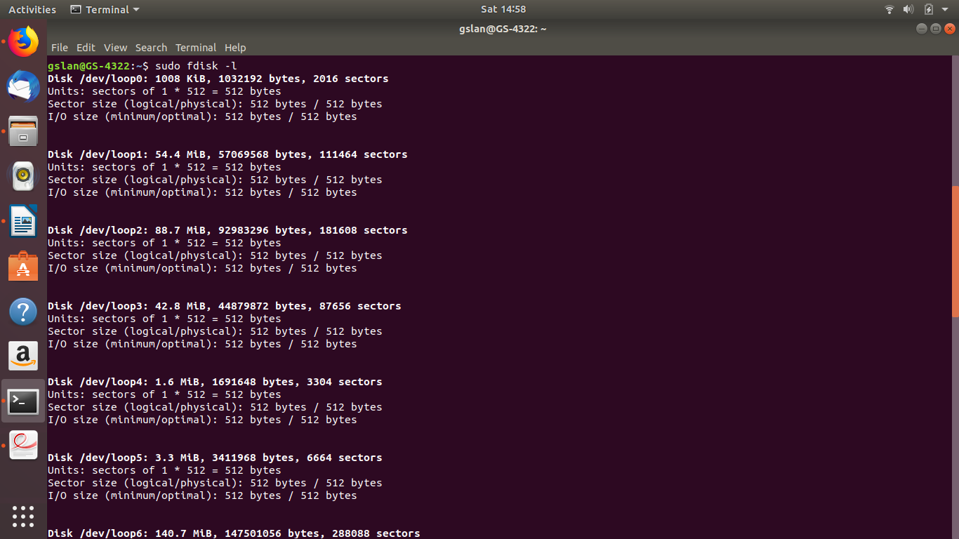
Command : sudo fdisk -l

8. Create a new group. Create a new user along with specifying a password for it.
Add this new user to the new group created and print these details for verification.

Commands: Creating User : sudo useradd UserName
Creating Group: sudo groupadd GroupName
Add members into group: sudo usermod -a -G GroupName UserName
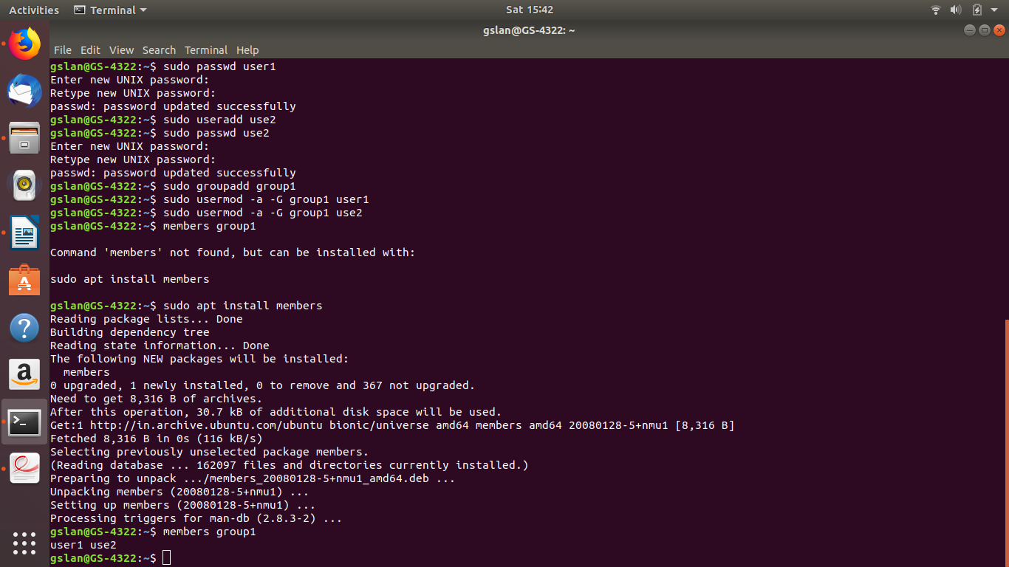

9.Locate a dimons running on the system.
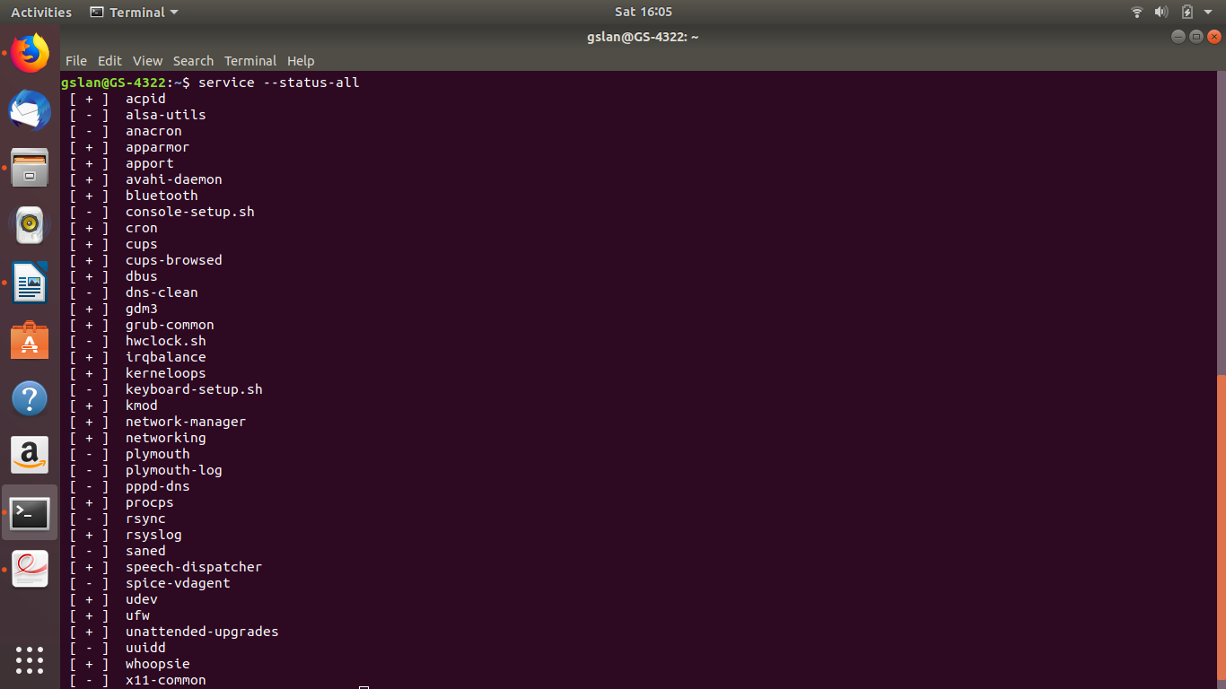
Command: service –status-all

10. Print A B C by putting space between B and C
Command: echo ‘A B C’

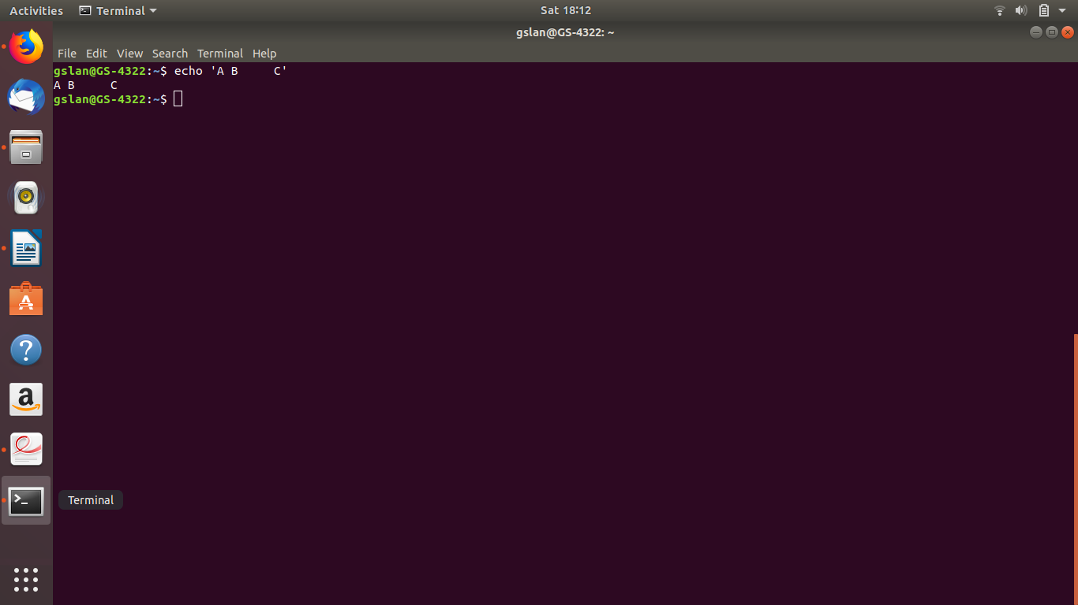
11 Use echo to display ??\\

Command :
1) echo ‘??\\’
2) echo “??”\\”\\”
3) echo “??\\”\\
4) echo -E ??\\\\\\
5) echo ‘??\’’\’

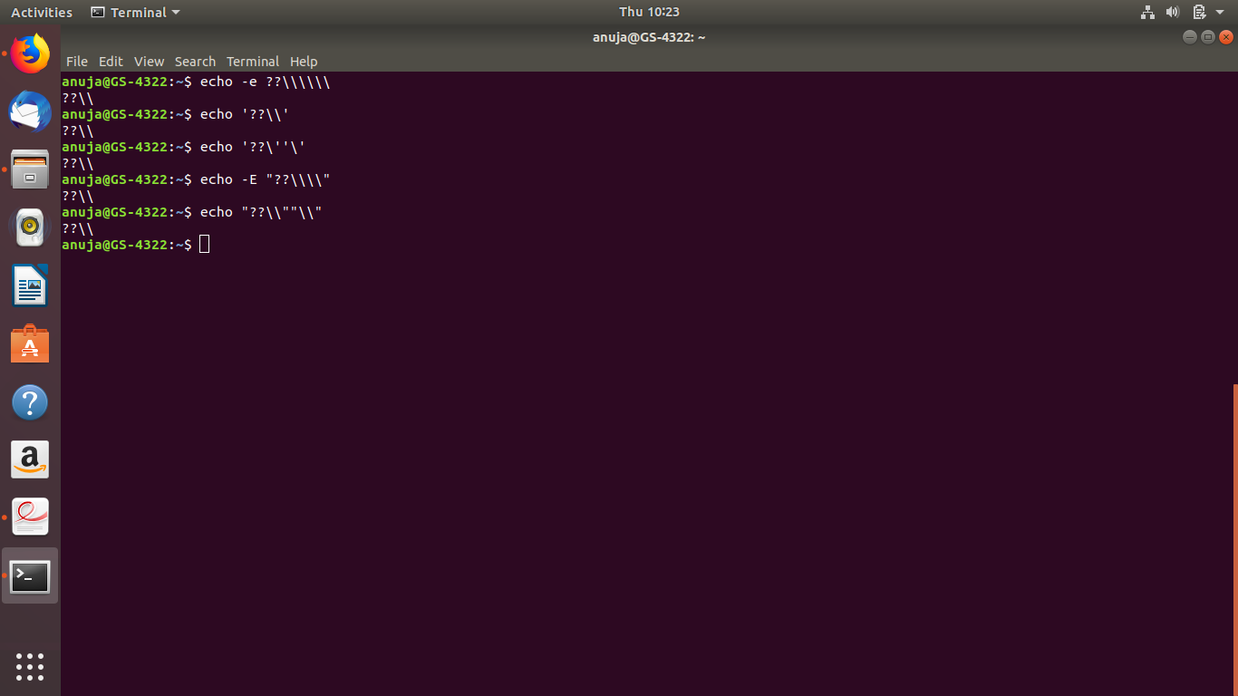

12. Write a ​ command that executes rm file55. Your command line should print 'success' if file55 is removed, and print 'failed' if there was a problem

Command: rm abc.txt && echo success || echo fail

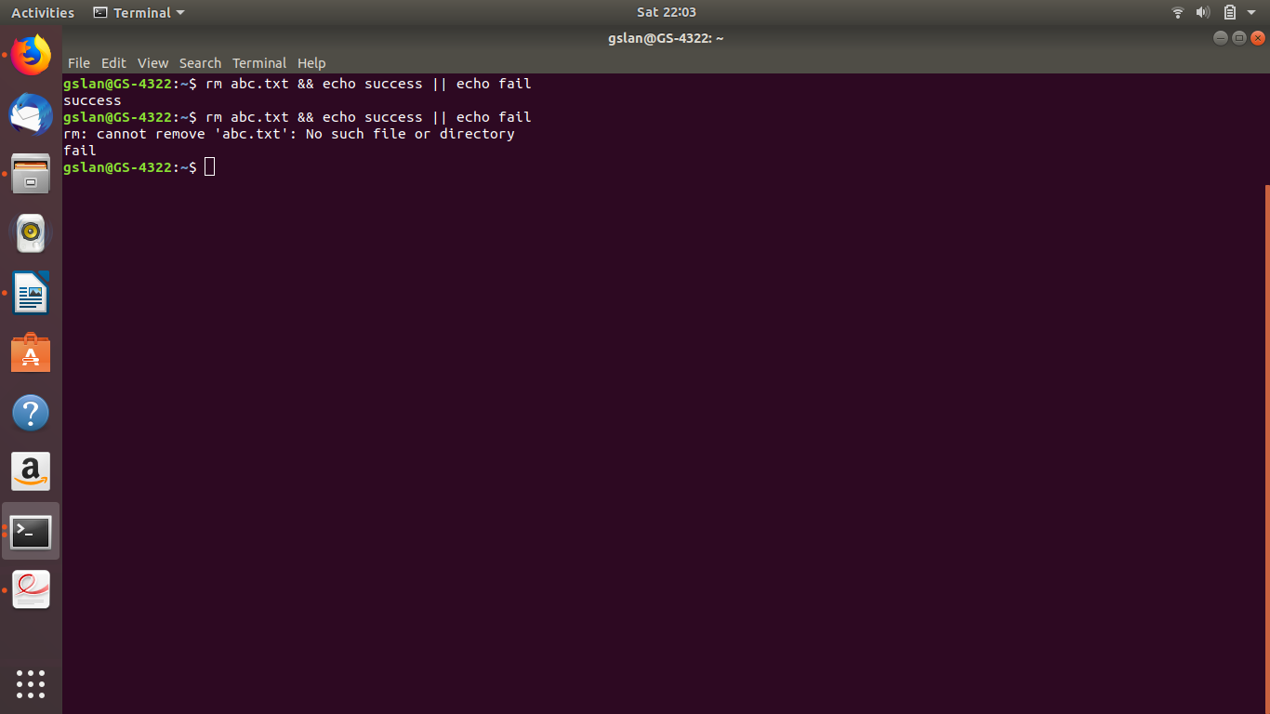

13. Create a script which takes ‘String’ type input from user and prints the number of lines, words and characters in it. Any input other than ‘String’ type, should result in an error.

14. Create a file with 10-15 lines of text and perform the following operations-

a. Replaces first occurrence of ​ the ​ with ​ THE ​ on every line of the file
-demo.txt
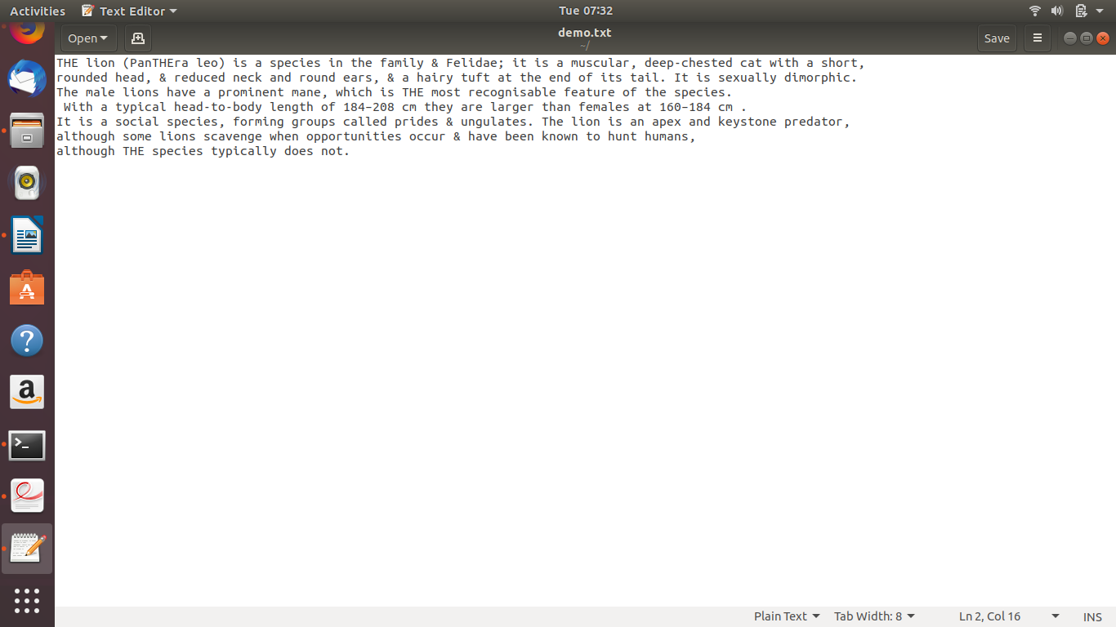
1. Command: sed -i ‘s/the/THE’ demo.txt
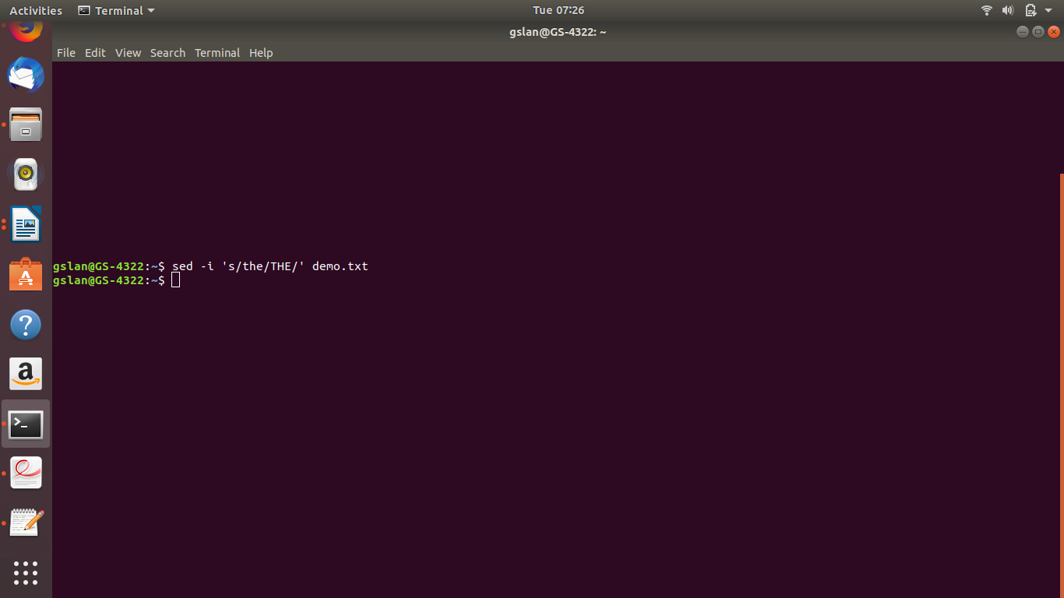

-Updated File.Demo.txt

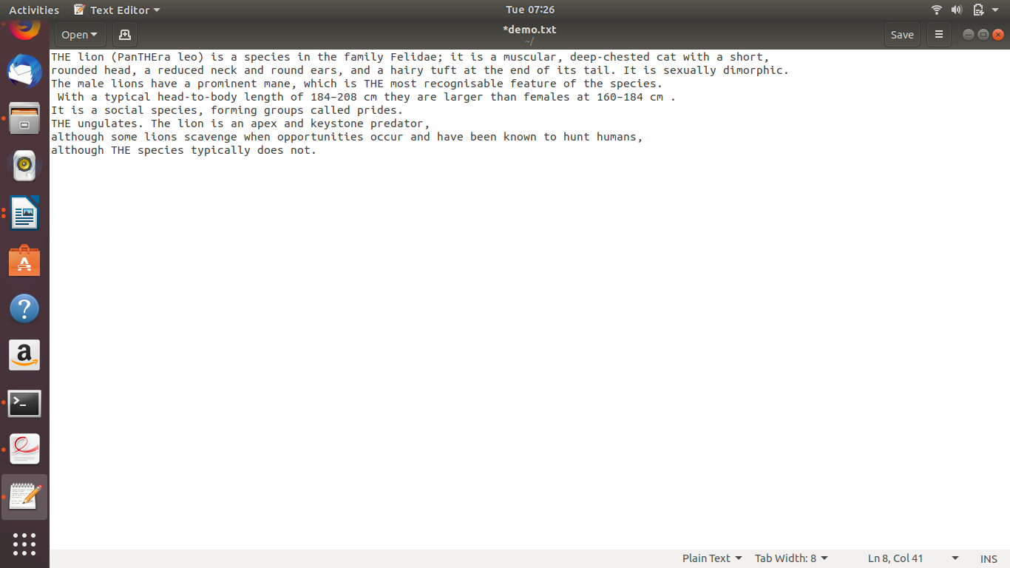

b. Replaces every occurrence of & (escaped) with "and"
Command:sed ‘s/&/and/g’ demo.txt
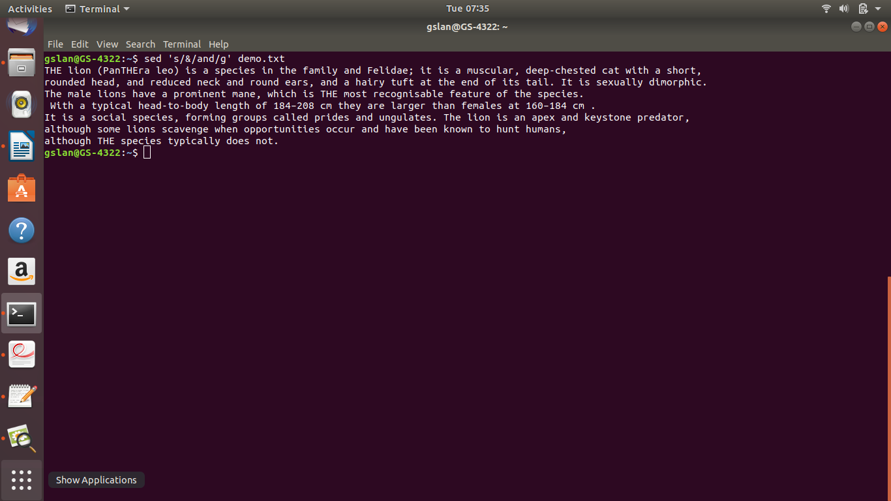

c. Put a ​ # ​ at the beginning of lines 5 through 10

Command: sed -i ‘5,10s/^/#/’ abc.txt

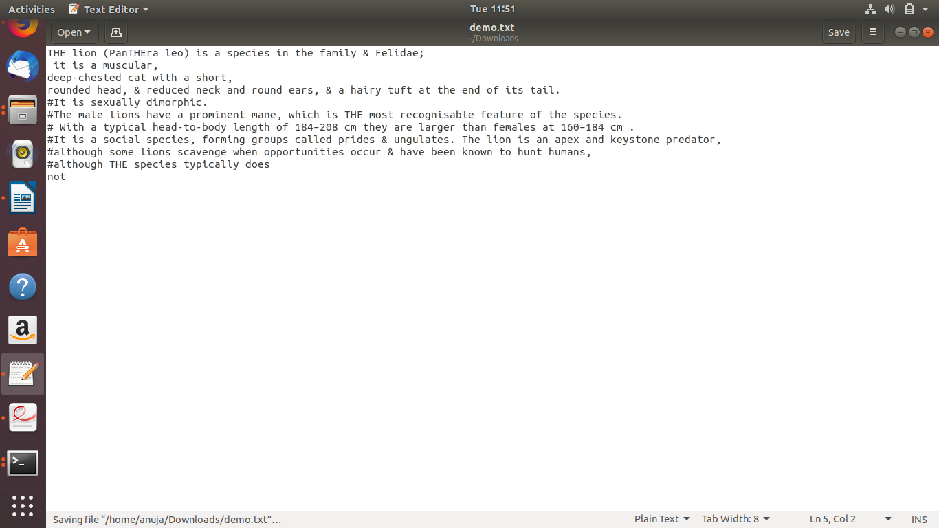

d. Do a "grep'' to find lines containing the word ‘a', then delete them
Command : grep -v -w “a” demo.txt

15. Install a libvirt/python package on your machine

Command: sudo apt-get install python-libvirt
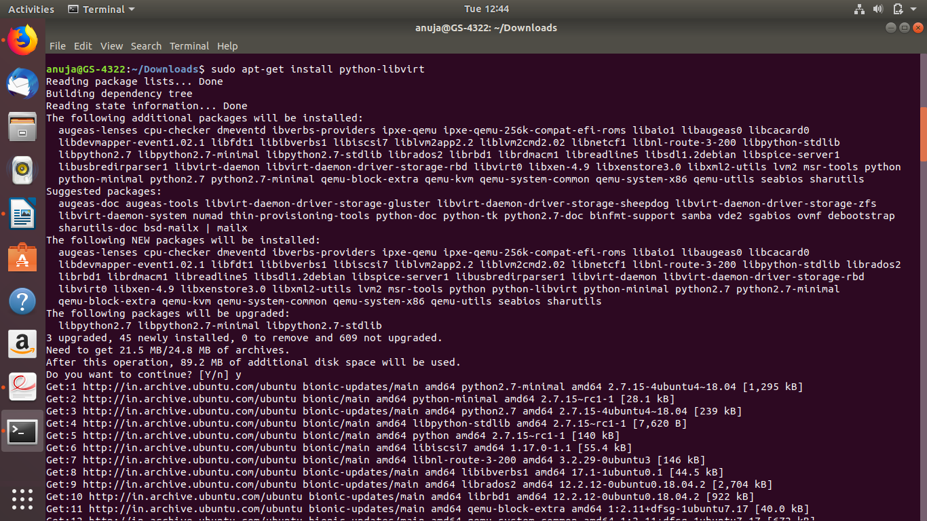

16. Download the following file using command line-
URL – \\10.136.63.249\Share\1.vmImages\cirros-0.3.4-x86_64-disk.img

Command: curl u share:gslab\!123 -O ftp://172.20.91.12/share/1.vmImages/cirros0.3.4x86_64-disk.img
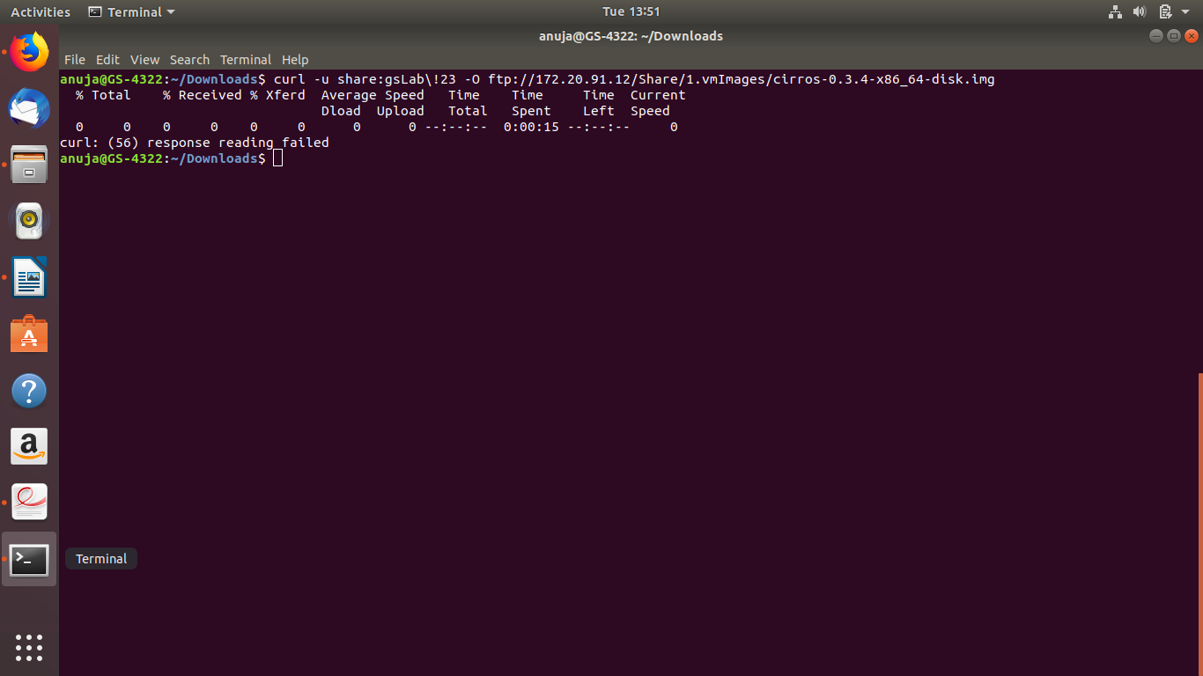

17. Display the type of file of cirros-0.3.4-x86_64-disk.img
Command: curl u share:gslab\!23 -O ftp://172.20.91.12/share/1.vmImages/cirros0.3.4x86_64-disk.img

18. You receive information that one of your servers was cracked, the cracker probably replaced the
ls command. You know that the echo command is safe to use. Can echo replace ls ? How can
you list the files in the current directory with echo ?

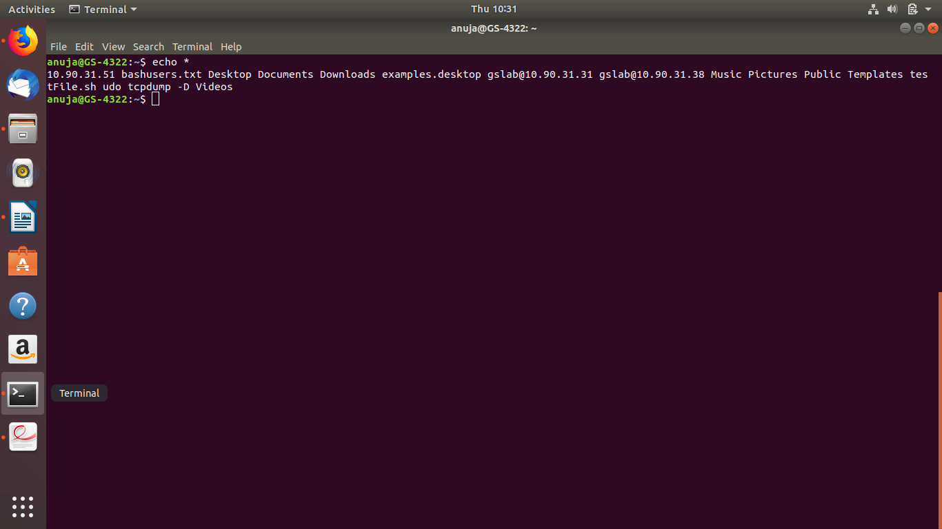

19. Put a sorted list of all bash users in bashusers.txt.
Command: who |user |unique >>bashusers.txt

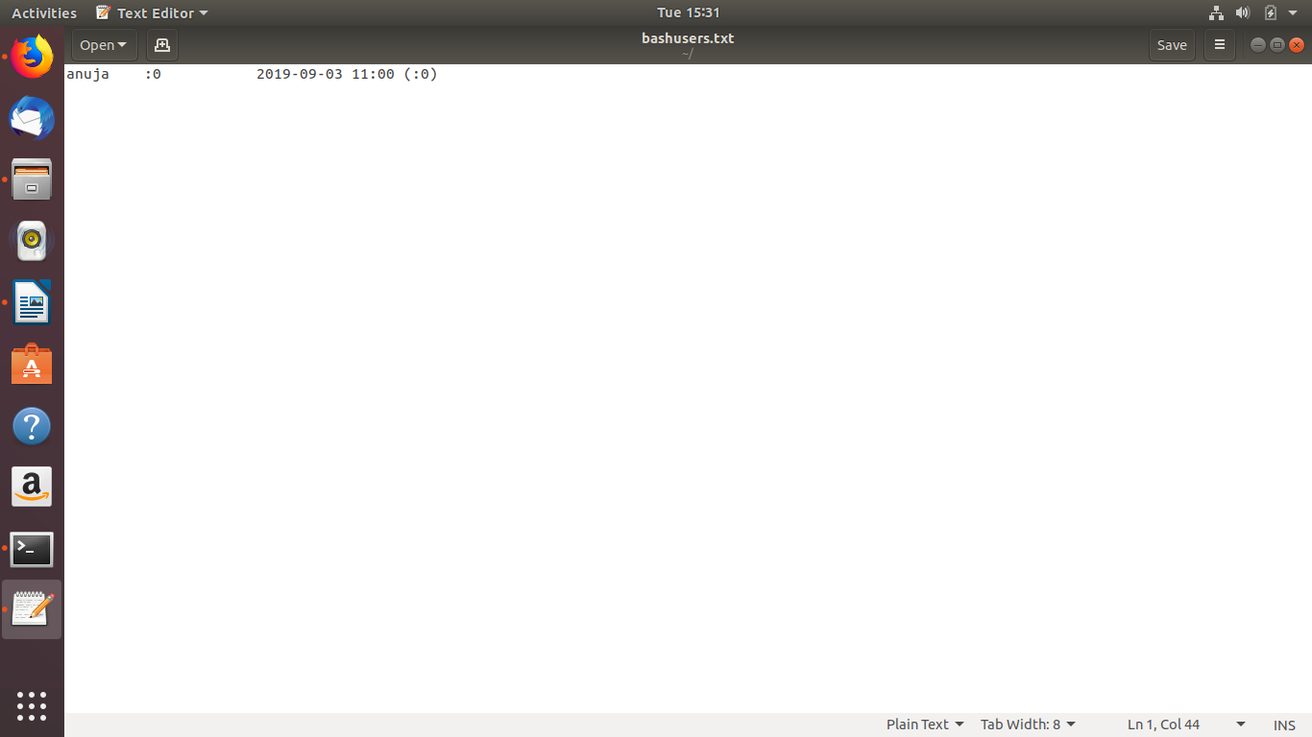

20. Look at the output of /sbin/ifconfig. Write a line that displays only ip address and the subnet mask
Command:
/sbin/ifconfig | grep ifconfig| grep netmask

